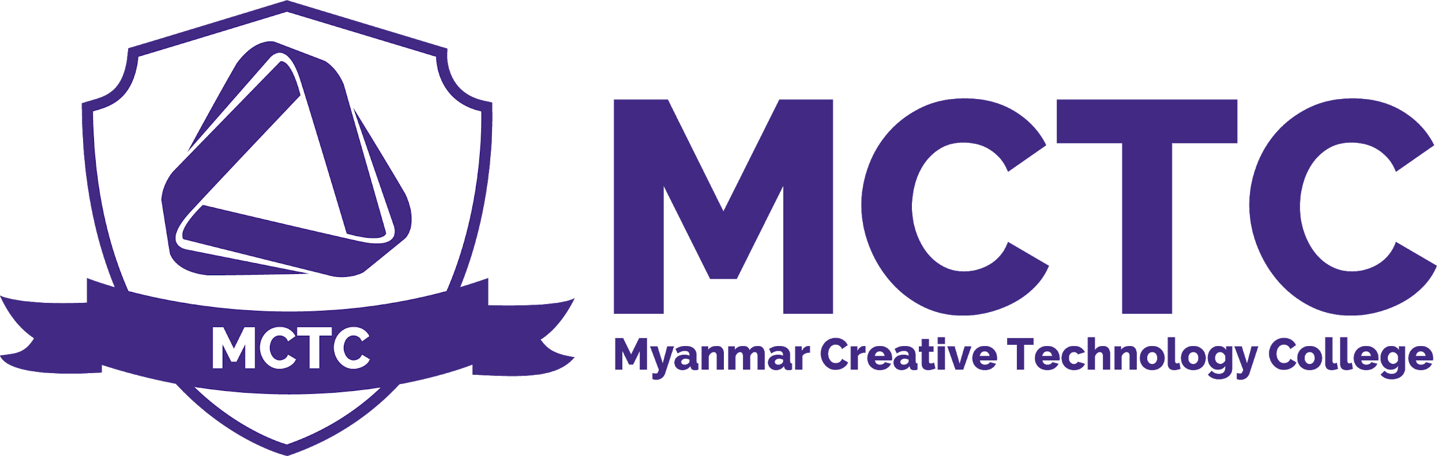

Learner Support Policy
Version: 1.0

Definition and Purpose

This policy is intended to provide staff and students with information regarding the facilities and resources that are available to students to support them with the academic , vocational and English language demands of their courses. The policy also outlines the expectations and responsibilities of staff to identify students with learning support needs and to direct them to or provide them with appropriate resources. Students are academic achievement and skill upgrade are defined regularly and the support strategies in place for every student.

Myanmar Creative Technology College Learner Support policy aims to provide a service involving initial and on-going guidance and support for individual learners to enable them to successfully participate and complete their learning programmes.

Scope
MCTC Management , BTEC Management , Academic Board , Students

Policy

Appropriate resources and structures are crucial in providing students, faculty and staff with the support they need to learn and to teach. Such structures also need to be sufficiently flexible to meet future needs, cope with changing patterns of learning and teaching, and facilitate improvements in the learning experience of students and the working environment for faculty and staff. In this context, it is important that learning and teaching are recognised as the primary processes of the institution.

Accordingly, the College will:

- Ensure the provision of inclusive learning through promoting equality, diversity and equal opportunity.
- Maintain physical, virtual and social learning environments that are safe, accessible and reliable for every student, promoting dignity, courtesy and respect in their use.
- Ensure that all those who are involved in teaching or supporting student learning at the College are appropriately qualified, supported and developed.
- Ensure that every student is provided with clear and current information that specifies programme aims, programme structure, learning opportunities and support available to them.
- Ensure that the College systematically engages with students and provides an atmosphere and culture which facilitates learning and meets expectations of the students.
- Ensure that students are given opportunities to consolidate and apply their learning in a range of ways through written, visual, physical, auditory and/or oral responses.
- Facilitate the design of learning and teaching activities by ensuring that appropriate resources are in place so that every student is given an effective opportunity to achieve the intended learning outcomes of the programme.
- Ensure that teaching is directed towards the goal of attainment of the learning outcomes as well as assessment criteria and that lecturers calibrate the progress of students against the assessment criteria and learning outcomes.
- Ensure that learning and teaching practices are critically reviewed at appropriate committees and that improvements are noted by reflection and evaluation of practices on the various academic reports produced by the College.
- Ensure that summative assessment is carried out for each unit and that written feedback is provided for each summative assessment with comments which are sensitive and constructive, making appropriate recommendations for improvement.
- The College will support Technology Enhanced Learning (TEL) and make use of digital opportunities and technologies to complement and align to traditional aspects of learning and teaching.

Support for Students and Their Learning

- A course induction programme is held in September introducing new students to the subject of study, higher level skills that need to be developed, and the college facilities (including the library, IT facilities, staff and other students).
- College and course/ module handbooks available in print and electronic format on Moodle.
- Personal and academic support is integrated in teaching provided by supportive and accessible tutors and identified 1:1 support sessions are also available.
- A modern well-equipped library and Up-to-date ICT equipment.
- Study skills sessions integrated in programme.
- Personal development planning sessions integrated into programme
Up-to-date Computer laboratories with specialist Macintosh computer facilities for computer networking and multimedia computing.
- Access to counsellors and support for students with special needs.
- Written assignment / assessment feedback (normally provided with 3 weeks of assessment submission).
- Regular 1:1 and group tutorial support
- Access to regularly updated course section and college wide sections on the college’s intranet Moodle
- Dedicated library of Graphics Video for taught sessions

Learner Support Policy

Person Responsible | CEO , Student Service ,Programme Leader , Academic Head
Approval Date
Version Number | 1.0
Approved by | CEO
Date of next formal review
Status

