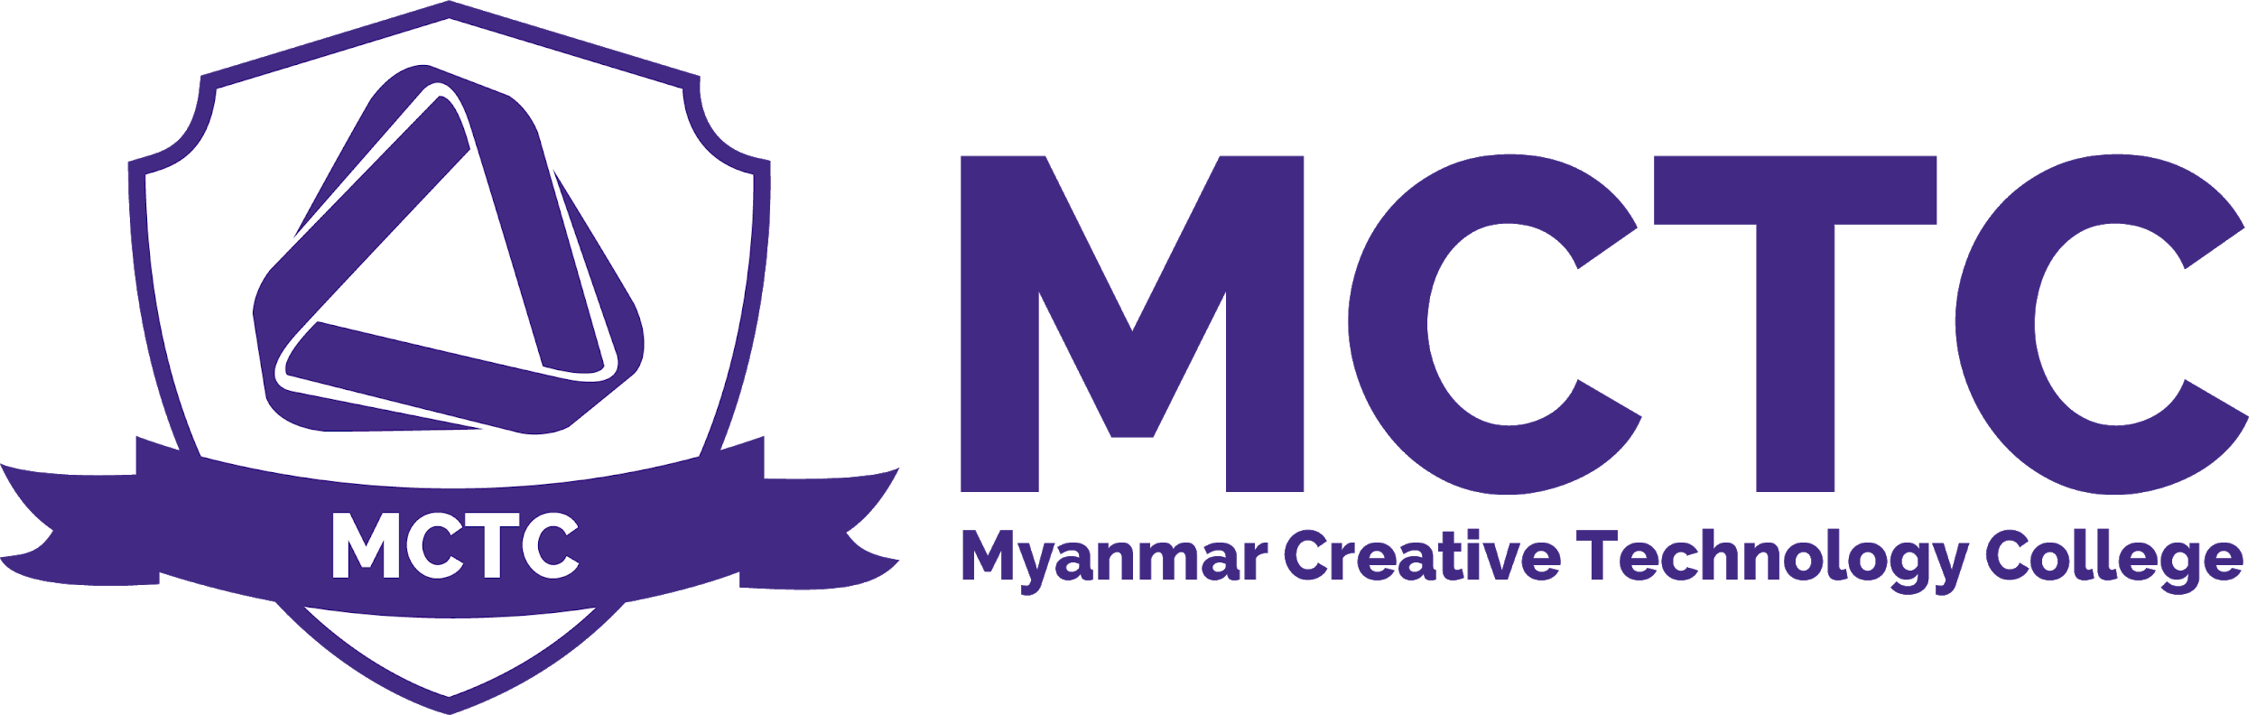

Complaints Policy
Version: 1.0

Definition and Purpose
A complaint is an expression of dissatisfaction about a situation that the person making the complaint wants to see rectified. The Student Complaint Procedure is intended to resolve students’ complaints related to College policies, programs, and services. The goal of the procedure is to allow students to exercise their due process rights with a simple and easily understood process.

Scope
MCTC Management , BTEC Management , Student Service , Students

Policy
Any student, or person acting on a student’s behalf, may express or file a complaint. All MCTC faculty and staff will refrain from any reprisal or threat of reprisal against any student registering a complaint.

The Student Complaint Procedure consists of two parts: making internal complaints (within MCTC) and making external complaints (to agencies outside of MCTC). When making an internal complaint regarding the handling of student education records, academic or behavioral conduct, harassment, sexual harassment, or grade appeals, the student complainant should consult with the student service officer and programme manager.

Process
Step 1: Informal Complaint
Students should first attempt to resolve concerns or complaints informally. To make an informal complaint, the student expresses his or her concerns or complaints to the faculty or staff member most directly involved. A student may make an informal complaint verbally or in writing. Students may request that the person’s supervisor be involved in this informal resolution process. Any student needing advice on how to begin an informal complaint should consult student service.

Step 2: Formal Complaint
If the student is not satisfied with the conclusions of the informal process, the student may make a formal complaint. Such complaints are made with an expectation that the College will formally investigate and provide a written summary of findings and action steps, if any. Students are normally required to go through the informal process before initiating the formal process.

To make a formal complaint, the student, or person acting on the student’s behalf, submits the complaint using the online Student Complaint Form, available at www.mctc-edu.com/complaint-form . Using the form helps to ensure that full information is provided and makes it easier for the College to respond to the student’s concerns. However, students can also use their own format for writing their complaint and then e-mail, mail, or deliver it to the Office of Student Affairs.

MCTC will conduct an investigation into the complaint, including interviews with relevant persons, a record review, or other efforts that are necessary to form an accurate and factual basis for the resolution of the complaint. Once the investigation is concluded, MCTC will prepare a brief written report that summarizes the complaint and a finding (either “founded,” meaning a violation has occurred, or “unfounded,” meaning the complaint is without merit). The written report will normally be provided to the student complainant and any relevant persons within 14 business days.

Complaints Policy

Person Responsible | CEO , Student Service ,Programme Leader , Academic Head
Approval Date
Version Number | 1.0
Approved by | CEO
Date of next formal review
Status

