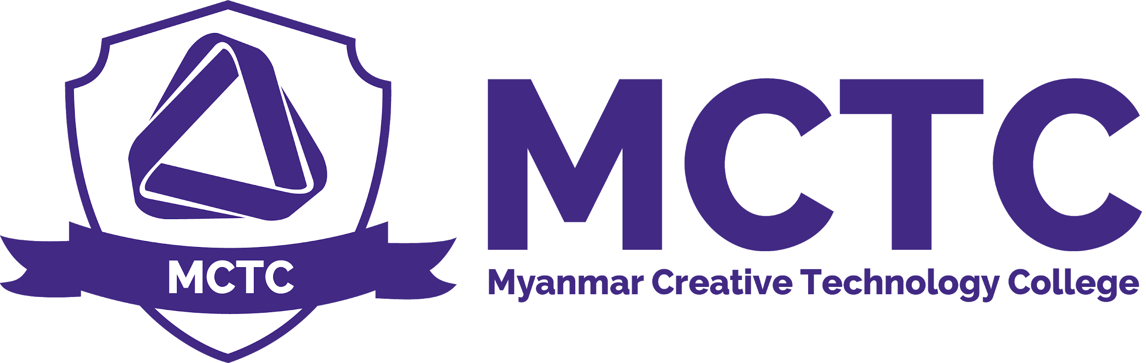

Maintenance Policy
Version: 1.0

Purpose and Policy
There will be two types of Maintenance for the physical facilities of Myanmar Creative Technology College. They are Planned Maintenance and Breakdown Maintenance.
The planned maintenance is classified into following types:
- Scheduled Maintenance (SM)
- Preventive Maintenance (PM)
- Corrective Maintenance (CM)
Scheduled Maintenance(SM)
For Scheduled Maintenance, the Technical team under the management of Operation Manager is assigned according to the schedules. The scheduled Maintenance will be taken all over the year continuously according to the schedule of Maintenance. The sample schedule is as follows; MCTC will update the schedule monthly.

Sample Maintenance Schedule
Maintenance Schedule
Date:
Prepared By:
Submitted to:
Approved By:
No. | Task Description | Task Duration | Due Date | Target Date | Resource  Names | Person  Responsible | Remark

Preventive Maintenance (PM)
The Preventive Maintenance starts immediately when new assets are entered. For example, Installation of Antivirus for the computers for prevention purpose.

Corrective Maintenance (CM)
The Corrective Maintenance takes place when there is unexpected and accident error occurs. For this option, the Technical team under the management of Operation Manager is responsible.

Maintenance Policy
Person Responsible | CEO , Management
Approval Date
Version Number | 1.0
Approved by | CEO
Date of next formal review
Status

