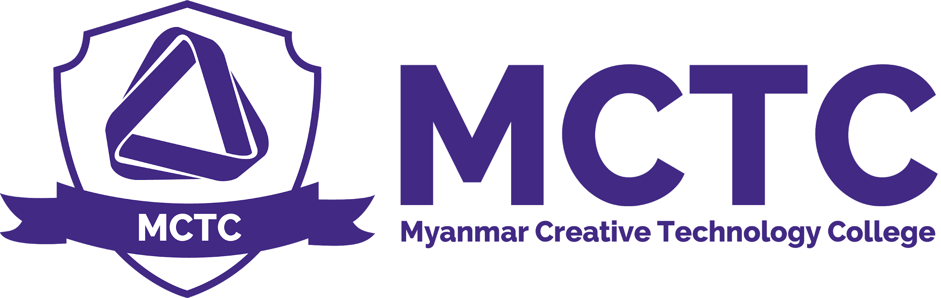

Appeal Policy
Version: 1.0

Definition and Purpose
Myanmar Creative Technology College has clear procedures for dealing with student appeals which form part of its quality assurance system and reflect current best practice. The procedures governing appeals against assessment outcomes are treated seriously without negatively affecting student rights or impartial judgement on academic progress.

Scope
MCTC Management , BTEC Management , Academic Board , Students

Policy
Appeals may be submitted within the boundaries set by these regulations when a student believes he or she has a significant concern related to the assessment process.

Grounds for requesting review of assessment board decision

Requests for review of an assessment board decision may be made on the grounds that:

(i) There was a material administrative error or other material irregularity in the conduct of the assessment (including accommodated assessment/reasonable adjustment for disabled students) or the application of the MCTC academic regulations.

(ii) Extenuating circumstances, which for valid reasons, had not been made known to the assessment board which had they been referred might have led the Assessment board to reach a different decision;

(iii) Any other matter which in all the circumstances ought properly to be considered by assessment board and college management in the interests of fairness.

Issues such as disagreement with the assessor on the grounds of academic judgement, specifically, disagreements on the merit of individual assessments in relation to marks, grades or other measures of performance excluded from the review.

Process
Students are given a period of 7 working days to appeal should they feel dissatisfied with the results.
If a student feels there are grounds for appeal, they can approach the Student Service for the necessary Appeal Form or You can Obtain Here
A Review of Grade will incur a fee of 50,000. The fee will only be refundable to the participant for a successful review.

Appeal Policy

Person Responsible | CEO , Student Service ,Programme Leader , Academc Head
Approval Date
Version Number | 1.0
Approved by | CEO
Date of next formal review
Status

