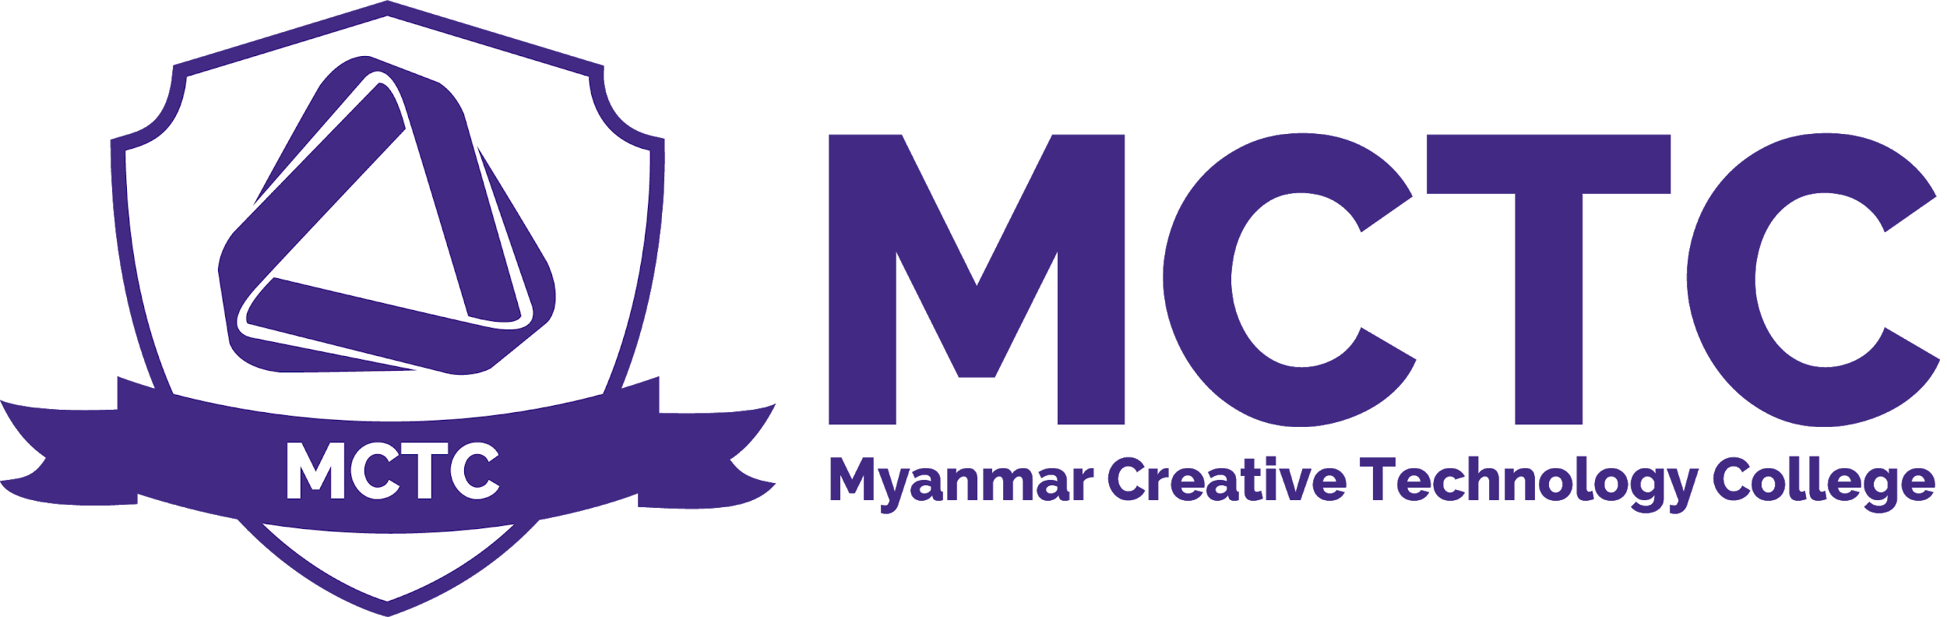

Contingency and Adverse Effects Policy
Version: 1.0

Purpose and Policy

The plan will be implemented in the event of major disruption to the system, such as widespread illness, travel disruption, bad weather or power failures. Any actions taken will be subject to the advice of the official agencies dealing with the specific circumstances being faced, for example the Police, Environment Agency or Health Protection Agency.

Implementing the plan will safeguard the interests of candidates while maintaining the integrity of the examination system and safeguarding qualification standards.

The contingencies applied will be selected based on the context of the disruption and have been implemented on several occasions in response to localised issues. They would be applied on a larger scale in response to any widespread disruption at a national level. The priority when implementing contingencies will be to maintain three principles: Delivering assessments to published timetables Delivering results to published timetables Complying with regulatory requirements in relation to assessment, marking and standards.

Criteria Code | Criteria for implementation of the plan | Action Plan
001- Disruption of teaching time – MCTC is closed for an extended period: | Myanmar Creative Technology College is closed or candidates are unable to attend for an extended period during normal teaching or study supported time, interrupting the provision of normal teaching and learning. | Where there is disruption to teaching time and students miss teaching and learning, it remains Myanmar Creative Technology College responsibility to prepare students, as usual, for examinations.  In the case of modular courses, we may advise candidates to sit examinations in an alternative batch/series
002-Candidates unable to take examinations because of a crisis - centre remains open: | Candidates are unable to attend Myanmar Creative Technology College to take examinations as normal. | MCTC will liaise with candidates to identify whether the examination can be sat at an alternative venue in agreement with the relevant awarding organisations. MCTCl will offer candidates an opportunity to sit any examinations missed at the next available series. MCTC will apply to awarding organisations for special consideration for candidates where they have met the minimum requirements. Candidates are only eligible for special consideration if they have been fully prepared and have covered the whole course but are affected by adverse circumstances beyond their control. If a candidate chooses not to sit an examination for other reasons they should be aware that special consideration rules will not apply.
003-Centre is unable to open as normal during the examination period | Myanmar Creative technology College is unable to open as normal for scheduled examinations. | If MCTC is unable to open as normal for examinations we will inform each awarding organisation with which examinations are due to be taken as soon as is possible. As part of our general planning for emergencies, we will cover the impact on examinations. The responsibility for deciding whether it is safe for a centre to open lies with the Head of Center (CEO). Head of Center (CEO) is responsible for taking advice, or following instructions from relevant local or national agencies in deciding whether we are able to open.
004-Disruption to the Transferring/Transportation of completed examination papers: | Delay in normal collection arrangements(Transferring/Transporting) for completed examination scripts. | In the first instance MCTC will seek advice from awarding organisations(Pearson)  We will not to make our own arrangements for further Transferring/transportation without approval from awarding organisations.  MCTC will ensure secure storage of completed examination papers until collection.
005-Assessment evidence is not available to be marked: | Large scale damage to, or destruction of, completed examination scripts/assessment evidence before it can be marked. | MCTC to generate candidate marks for affected assessments based on other appropriate evidence of candidate achievement as defined by the awarding organisations.  Candidates to retake affected assessment at subsequent assessment window
006-Centre is unable to distribute results as normal: | Myanmar Creative Technology College is unable to access or manage the distribution of results to candidates, or to facilitate post results services. | MCTC Will contact awarding organisations about alternative options: make arrangements to access its results at an alternative site;  Or remind students about physically printed results sheet at Centre as well.

Contingency and Adverse Effects Policy
Person Responsible | Board , Management
Approval Date
Version Number | 1.0
Approved by | CEO
Date of next formal review
Status

